**ENGN 2605 Lab 1: PointWise Image Processing**

**Instructor: Prof. Benjamin Kimia**

**Name: Kuan-Min Lee**

**Problem 1. Thresholding**

**Single Thresholding Case:**

This part involves with setting up binary thresholding for the original image of white blood cells. The original image is shown as follow:

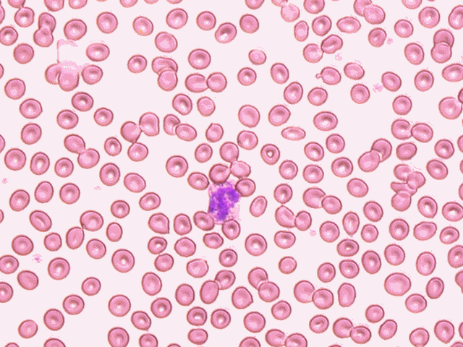

Figure 1: Original Image of White Blood Cells

Based on the criteria from the manual, we are required to conduct the following quantization:

(New Image (i,j): new image pixel,

i: index for height of the image, j: index for width of the image)

To conduct a reasonable thresholding, a sample image of a white blood cell from the image is cropped as shown as below:



Figure 2: Sample White Blood Cell Image Cropped from Original Image

From this cropped image, its mean and standard deviation are calculated.

|  |  |
| --- | --- |
| **Table 1: Data for Region of White Blood Cell Image** | |
| **Mean** | **Standard Deviation** |
| 193.33 | 42.03 |

Empirically, the threshold was set to 1.323 standard deviation above the mean, and work as follow:

(New Image (i,j): new image pixel, I (i,j): original image pixel,

i: index for height of the image, j: index for width of the image,

Mean: mean value of white blood cell image, StD: standard deviation of white blood cell image)

The final outcome of the thresholding is as follow:

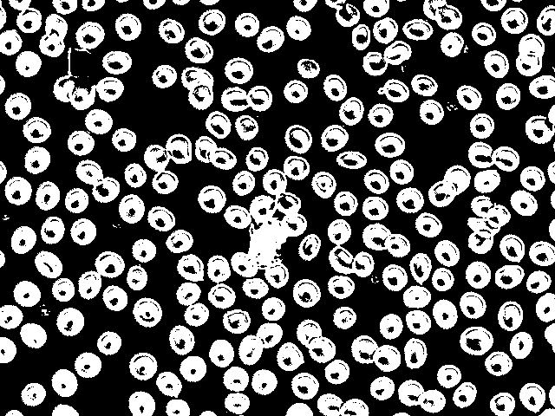

Figure 3: Thresholding of the White Blood Cell Image

From the above figure, there is some black noise inside the cell portion. Why this happens can be due to the fact that in the original image, the white blood cells contain some shades inside the cell portion. Therefore, the performance of the thresholding is also affected by that.

**Bilevel Thresholding Case:**

For this part, instead of having one single threshold for thresholding, it involves in conducting thresholding with two different levels. Based on the description of the manual, a specific range of pixel values is needed to filter out. The image being tested is shown as below:

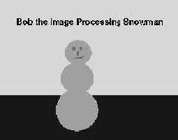

Figure 4: Snowman Figure that Used for Testing

Following the same idea from the previous section, the two region of interest images are created to set up the thresholds:



Figure 5: Region of Interest 1: Background



Figure 6: Region of Interest 2: Ground

Once again, their means and standard deviations are calculated and used as the purposes for setting up the thresholds:

|  |  |  |
| --- | --- | --- |
| **Table 2: Data for Regions of Interest of Snowman Image** | | |
|  | **Mean** | **Standard Deviation** |
| **Region of Interest 1** | 215 | 0 |
| **Region of Interest 2** | 23 | 0 |

Since image 2 is a highly uniform image in term of colors in each region, the valid interval for thresholding is set to be [23,215]. Therefore, the function works as below:

(New Image (i,j): new image pixel value, I(i,j): original image pixel

i: index for image length, j: index for image width)

The final outcome image is shown as below:



Figure 7: Final Filtered Snowman Image

From the above figure, there are lots of noises coming out at the edge portions of the image. Due to the low resolution of the original image, lots of jaggers have been observed in those regions. As a consequence, the filtered image is not ideal.

The following figures show the jagger portion of the image:



Figure 8: Jagger 1: Edge Portion (Color Constancy)



Figure 9: Jagger 2: Snowman and Ground Adjacent



Figure 10: Jagger 3: Word Edge with Background

In figure of jagger 1, the color of the region that is between the ground and background is consistent to neither the color of the background nor the ground. This scenario will create some artificial inconsistency on the thresholding. In figure of jagger 2 and 3, some jaggers can be observed on the edge portions, which will further lead to the resulting of noises.

However, a common way of suppressing the effect of noises of an image is to apply Gaussian filter. The following figure is the outcome of applying gaussian filter with standard deviation of 2:

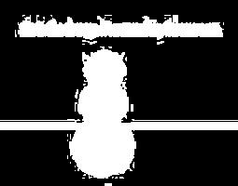

Figure 8: Filtered Snowman Image after Gaussian Filtering

**Problem 2. Contrast/Inversion**

**Contrast**

This portion involves in adding and subtracting every pixel of an image to adjust its brightness. The following are the original image and the results of adding and subtracting every pixel by 25.

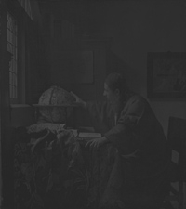

Figure 9: Original Image

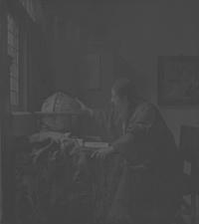

Figure 10: Result of Adding the Value of 25 at Each Pixel

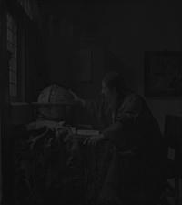

Figure 11: Result of Subtracting the Value of 25 at Each Pixel

For this case, the image can enhance its visibility by increasing the value of each pixel, but it can also deteriorate its visibility by subtracting all of them.

**Inversion**

This portion involves in the conversion of color of an image. Since each image is a colored one, each image will contain three individual channels, one for red channel, another one for green channel, and the other one for blue channel. Therefore, the image will first need to conduct color inversion separately and then concatenate back to form the new image, the color inversion mechanism is shown as below:

(New Image (i,j): New Image Pixel, I (i,j): Original Image Pixel)

The final outcome of the color inversion is shown as below:

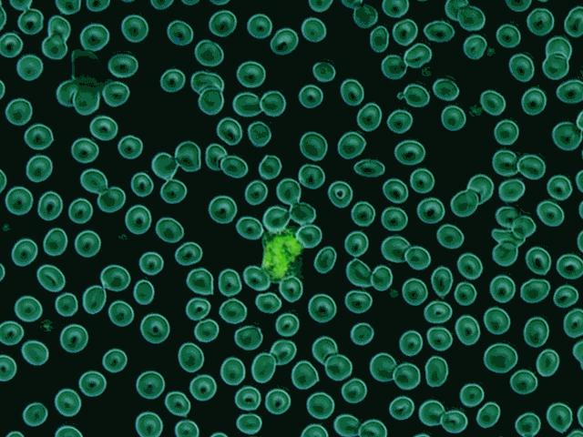

Figure 12: Result of Color Inversion

**Problem 3 Quantization**

**8-level Quantization**

The first part of the problem involves in quantizing the color of the image into 8 different levels. For grayscale image, there are 256 different pixel values ranging from 0 to 255. Therefore, taking the first level of quantization, the quantization will work as follow:

And

In other word, if the original pixel value falls into the first level interval, then the pixel value of quantized image will be the median of that interval.

The following plot is the result of the 8-level quantization:

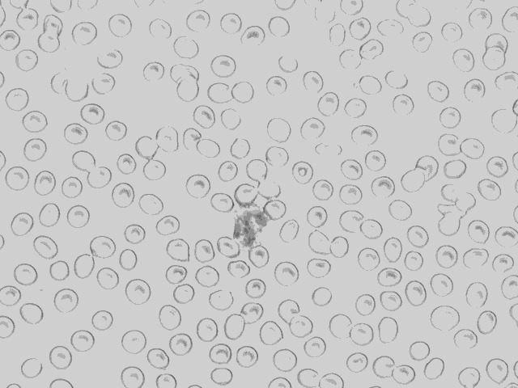

Figure 13: Result of 8-level quantization on White Cell Blood Image

**16-level Quantization**

For testing, 16-level quantization is also conducted:

And

And the final outcome is shown as below:

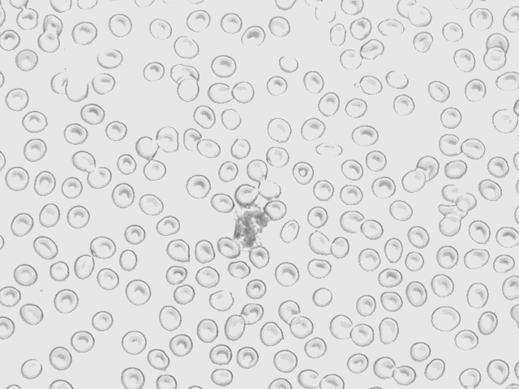

Figure 14: Result of 16-level quantization on White Cell Blood Image

Compared with the 8-level quantization, the visibility of the image is better. This fact can be proven by the clearer edges shown in the 16-level quantization outcome. Therefore, the conclusion that more levels of quantization can lead to a better result can be made.

**Sampling**

This part involves in skipping every other pixel to reduce the resolution of the original image. In other word, the sampling rate of every 2 pixel is conducted.

The mechanism of sampling rate of 2 is displayed as follow:

The following is the result of sampling rate of 2:

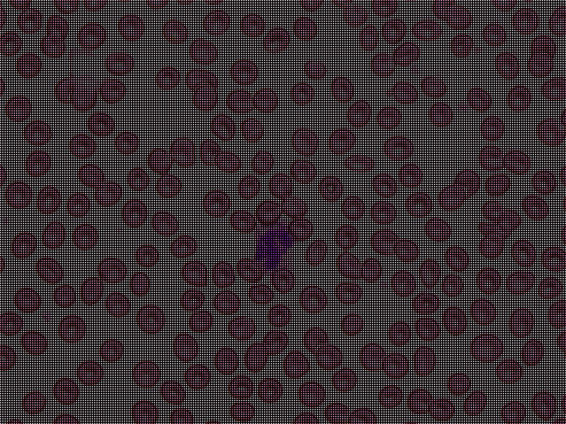

Figure 15: Result of Sampling Rate of 2 on White Cell Blood Image

To make comparison, a sampling rate of 7 is also conducted:



Figure 17: Result of Sampling Rate of 7 on White Cell Blood Image

The result shows that as the sampling rate increases, the brightness of the image decreases.

**Playing with Camera**

**Mean and Standard Deviation Image**

In this section, twenty images of the same scene are taken to conduct this experiment. The following shows one of the sample images:

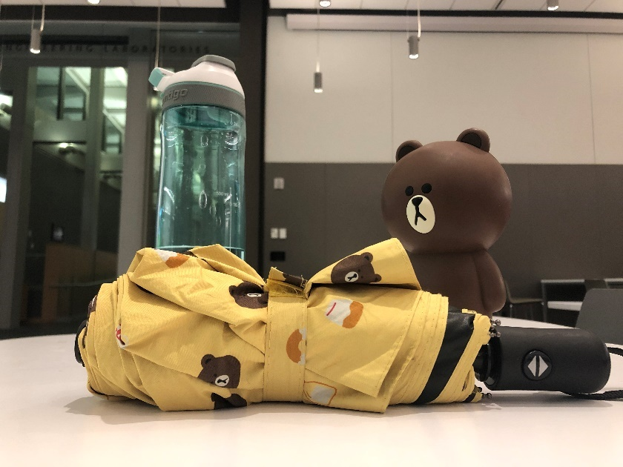

Figure 18: One of the Sample Image from the 20-image Collection

To obtain its mean image, each channel from the image is first separated and then be stored into individual variables. For RGB image, since the images have 3 channels. Therefore, 3 different variables are needed to store the data from each channel from those images. After finishing storing all 20-image data, the mean of each channel along the 3rd dimension will be conduct to create a single channel matrix for each variable, and then all these 3 variables will then be concatenated back to form a RGB image:

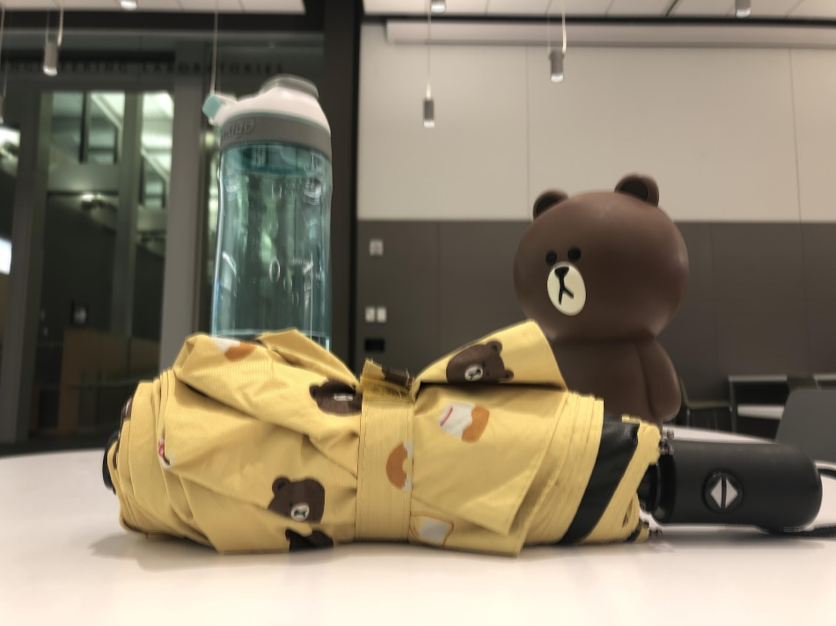

Figure 19: Result of the Mean of Each Channel

The final mean calculation will be conducted on this image channel wise to form the final mean image:

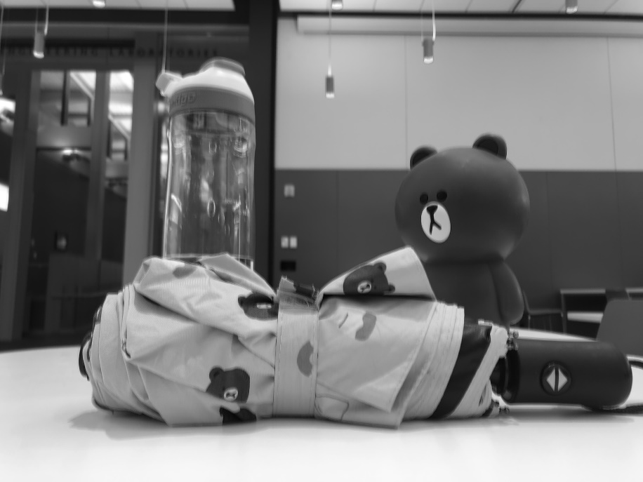

Figure 20: Result of the Final Mean Image

The final standard deviation image is shown as below:

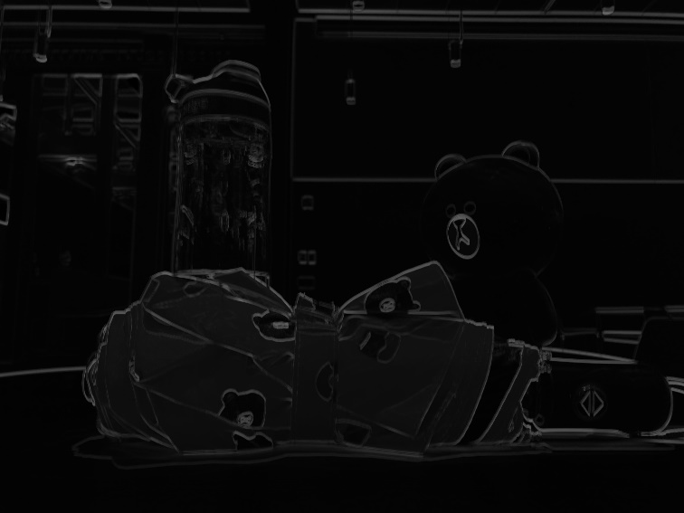

Figure 21: Result of the Final Standard Deviation Image

The standard deviation image represents the part where the noise (or error) happens. Based on the above observations, the part that noise often happen in the edge portion, which might happen due to different reflection from the light sources.

**Maximum Difference**

To conduct the maximum difference of the mean image, the maximum and value of the pixel was extracted to conducted the subtraction. The magnitude of the maximum difference is 251. The maximum is indirectly associated to the mean of the image. A more appropriate way of addressing its relationship to the image is the maximum difference is more related to the lightness difference of the background, which is somehow related to the mean of the image.

**Histogram**

Since each image is a RGB image, there will be three histograms for each channel. The tested coordinate in the section is at (2903, 2360), which is shown in the following figure:

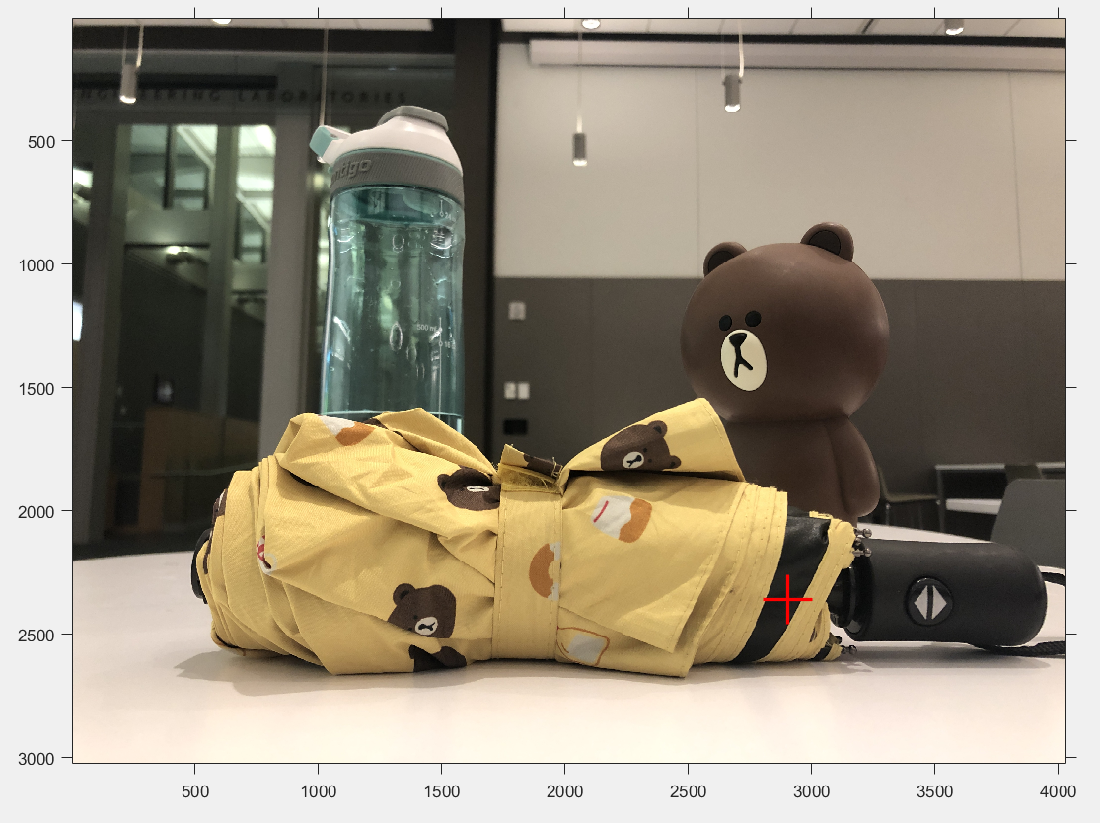

Figure 22: the Point That Is Being Tested

The following histograms are at coordinate (2903, 2360) of R, G, and B channel individually:

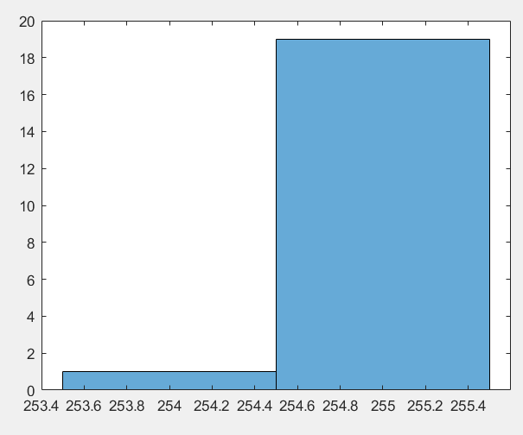

Figure 23: the Histogram of the R Channel

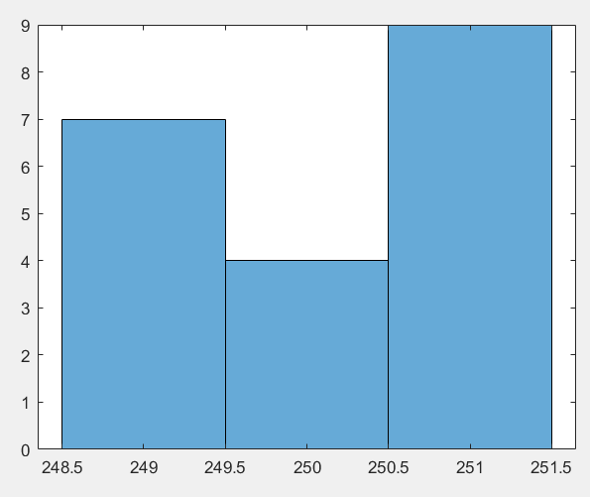

Figure 24: the Histogram of the G Channel

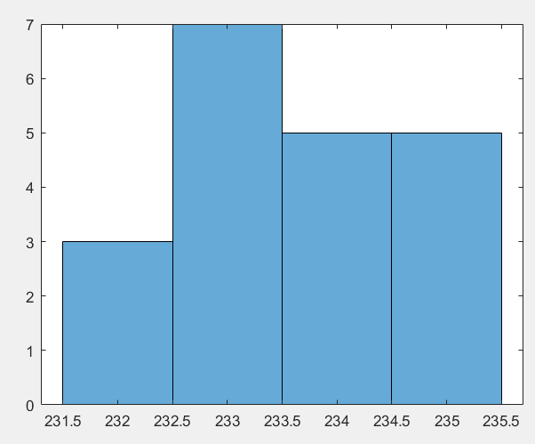

Figure 25: the Histogram of the B Channel

Since this point is a dark one, which rarely reflect lightness from the environment no matter what position we are at to take the photo, the pixel values across the image collections barely changes. Therefore, the distribution of the pixel values mostly follow the pattern of uniform data distribution.